**APONTAMENTOS DA FORMAÇÃO**

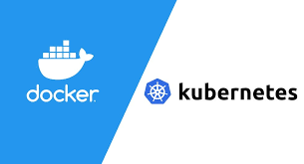

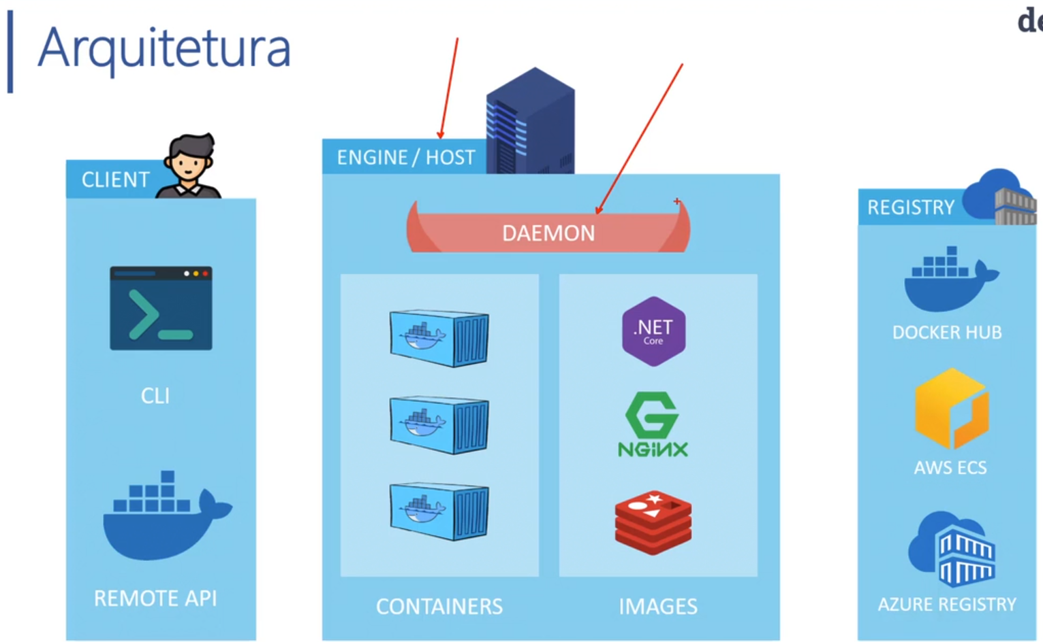

**Fundamentos do Docker**

1. **CRIAÇÃO DE CONTAINER**

* docker run dodcker/welcomo-to-docker:latest
* docker run --name meu-container -d -p 8088:80 docker/welcome-to-docker:latest

1. **RODAR CONTAINER JÁ CRIADO**

Se já haver container existente o comando é diferente:

docker start meu-container

docker start aa7446d19c2bf820ac3157216b9e133b53056445cf7ca575bf5719c4fa30ec61

1. **COMANDOS BÁSICOS DO DOCKER**

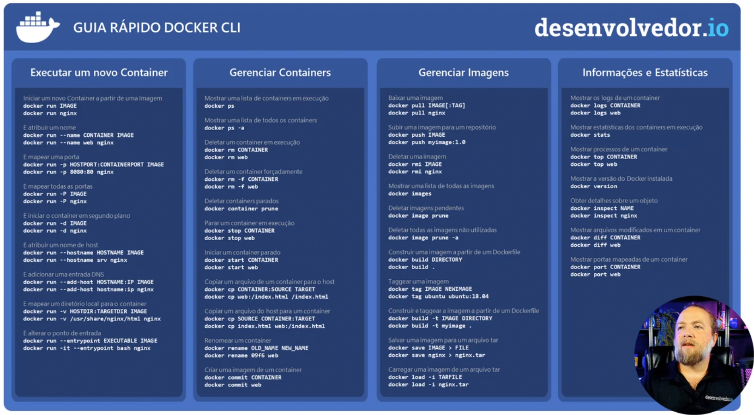

exec -it some-rabbit /bin/sh

COPIAR IMAGEM DO DOCKER PARA O PC LOCAL, COPIAR DO PC LOCAL PARA DOCKER RESPECTIVAMENTE

1. docker save -o "C:\docker\rabbitmq.tar" a4e86f36e8fd (vermelho é ou id da imagem)
2. docker load -i "C:\docker\rabbitmq.tar" – copiar a minagem

**Outra forma e pelo CMD abrir direito a pasta ou cegar la e abrir o cmd**

1. docker save -o "rabbitmq.tar"
2. docker load -i "rabbitmq.tar"
3. docker tag a4e86f36e8fdc3b4ad639111b1a0b97ccdda4610f9951b7d0cb8e2764665ab30 imagem-carregada:latest

REDES NO DOCER

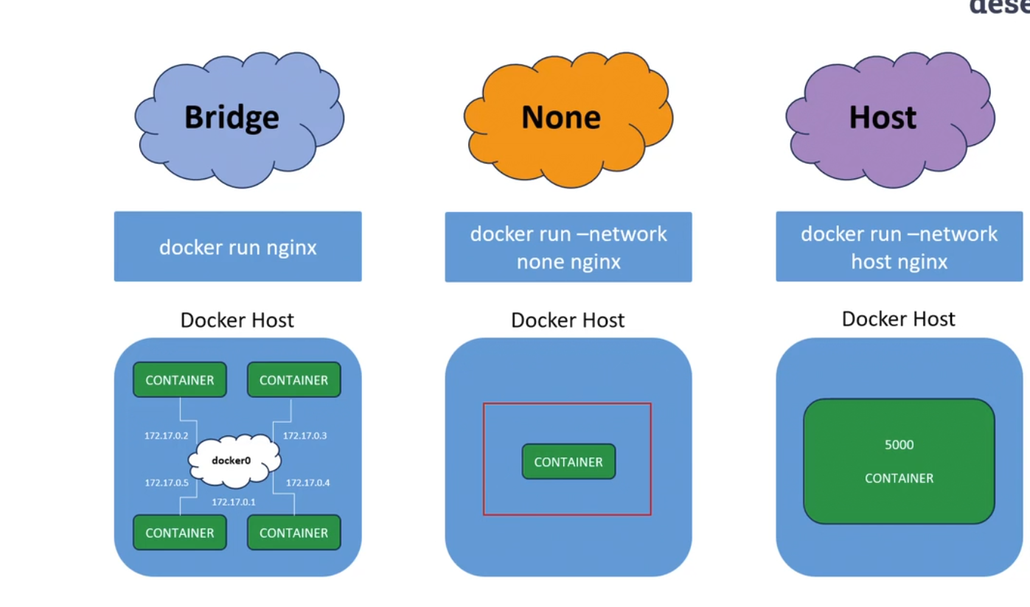

Comandos

1. docker network ls - Listar todas as redes do docker
2. docker network inspect bridge - Saber se rede esta atender ao container

Criando para redes em docker

1. docker network create --driver bridge minha-rede - Criar nova Rede;
2. docker network ls - Listar todas as Redes;
3. docker run --name nginx2 --network minha-rede -d nginx - Criar container na rede nova;
4. docker network disconnect minha-rede nginx2 - Retitar o container da rede
5. docker network rm minha-rede - Remover a Rede
6. docker network inspect minha-rede - inspecionar a minha-rede
7. docker network connect bridge nginx2 - Connectar nginx2 na rede bridge
8. docker network connect minha-rede nginx2 - nginx2 conectado em duas redes
9. docker network inspect minha-rede / docker network inspect bridge

Docker rorando online

Portainer.io 🡪 Roda em Navegador

<https://docs.portainer.io/start/install-ce>

<https://docs.portainer.io/start/install/server/docker/wsl>

**COMANDOS**

* docker volume create portainer_data
* docker run -d -p 8000:8000 -p 9443:9443 --name portainer --restart=always -v /var/run/docker.sock:/var/run/docker.sock -v portainer_data:/data portainer/portainer-ee:latest
* <https://localhost:9443>

# Initial setup

Once the Portainer Server has been deployed, and you have navigated to the instance's URL, you are ready for the initial setup.

## Creating the first user

Your first user will be an administrator. The username defaults to admin but you can change it if you prefer. The password must be at least 12 characters long and meet the listed password requirements.

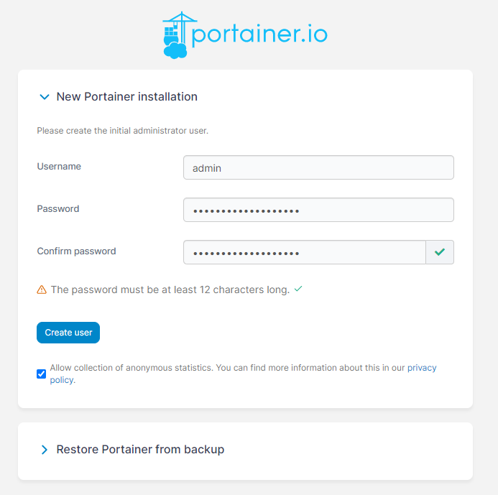

## Enabling or disabling the collection of statistics

We use a tool called [Matomo](https://matomo.org/) to collect anonymous information about how Portainer is used. We recommend enabling this option so we can make improvements based on usage. For more about what we do with the information we collect, read our [privacy policy](https://www.portainer.io/privacy-policy).

During installation, you can enable or disable connection statistics using the checkbox. If you change your mind later, you can easily update this option under [Settings](https://docs.portainer.io/admin/settings) in the Portainer UI.

https://docs.portainer.io/~gitbook/image?url=https%3A%2F%2Fcontent.gitbook.com%2Fcontent%2FtLcRoAdw9BYwwpba4ZAD%2Fblobs%2Fxlvsei3pVFudXI47tpB6%2F2.15-install-server-setup-matomo.png&width=768&dpr=4&quality=100&sign=963998a3&sv=1

## Add your license key

You will now be asked to provide your license key. You will have been provided this when signing up for Business Edition or the free trial. If you don't have a license key, you can either click the **Don't have a license?** link or [get in touch with our team](mailto:success@portainer.io).

Paste the license key you were provided into the box and click **Submit**.

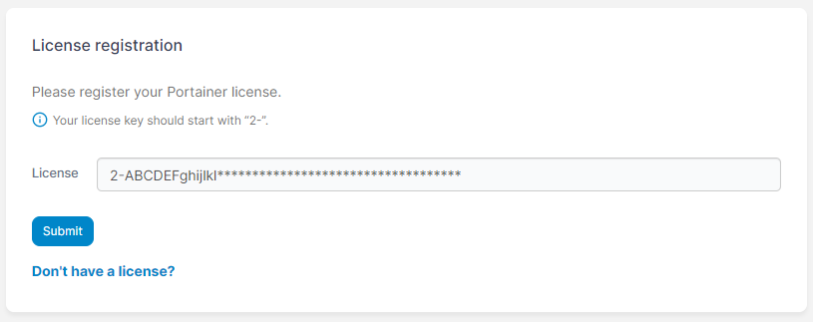

## Connecting Portainer to your environments

Once the admin user has been created, the **Environment Wizard** will automatically launch. The wizard will help get you started with Portainer.

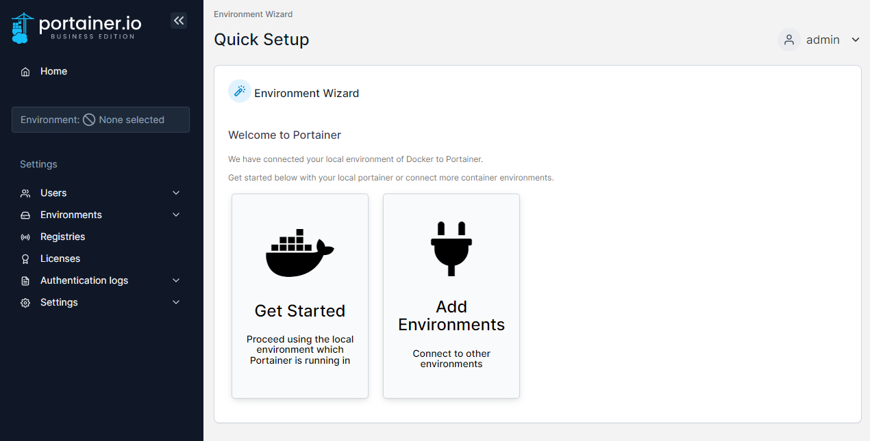

The installation process automatically detects your local environment and sets it up for you. If you want to add additional environments to manage with this Portainer instance, click **Add Environments**. Otherwise, click **Get Started** to start using Portainer!

# Volumes no docker

Comando para criar um volume. Vai rodar um ficheiro html na minha maquiquino no disco c:\doerk



Divisçoes do comando

